DRAFT – Confidential

Operating Characteristics Of UK CDFIs That Lend To SMEs
April 2023

The Purpose of this Paper
The purpose of this paper is to highlight characteristics which are common to CDFIs that lend to SMEs and to point out differences where they exist. In so doing it aims to provide an insight into their scale and operating models of these institutions. By making the finances and risks of CDFIs more transparent Responsible Finance aims to support the development of its members, unlocking inclusive economic growth and levelling up communities.

The Data Sample
There are around 20 CDFIs in the UK who lend to SMEs. 15 of these responded to the 2022 Responsible Finance annual survey. This review uses data from a subset of 10 CDFIs who have provided more detailed information in relation to loan performance, P&L, balance sheets and financial structure than in previous surveys. These 10 CDFIs represent around 75% of SME loan advances made by CDFIs in 2022
This dataset is a small step on the journey towards a more comprehensive and consistent reporting of the financial performance and risk outcomes achieved by CDFI lenders.
Enhancing the quality and usefulness of data collected from CDFIs remains a work in progress but we believe this new dataset represents a step forward. Critically it provides a new insight into the scale, structure and risk-taking of a substantial portion of SME lending by CDFIs. There are other datasets – such as the Community Investment Enterprise Facility – which also provide interested parties with more detailed information on the risks of investing in CDFIs.
Throughout this document “originations” are defined as loans which are consolidated onto the CDFI’s balance sheet. They exclude loans which are originated for other programs such as SULCO.

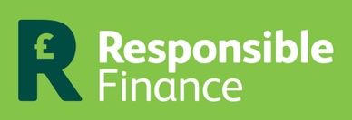
What does this report cover?
It attempts to address the following questions:
- How many years have they been operating for?
- What rates do CDFIs lend at?
- What origination fees do CDFIs charge?
- What is the average term of a CDFI loan?
- What is the average size of a CDFI loan?
- How much CDFIs lend each year?
- What is the value of loans on CDFI’s balance sheets?
- How much external funding did CDFIs raise in 2022?
- Where did the CDFI funding come from?
- What is their cost of funding?
- What are their net interest margins of CDFI lenders?
- What % of CDFI loans are more than 90 days in arrears?
- What is the current level of loan loss provisioning?
- What has been the cumulative bad debt write-off since establishment?
- What use do CDFIs make of loan guarantees?
- How profitable were CDFIs in 2022?
- What does a typical CDFI profit and loss account look like?
- What does a typical CDFI balance sheet look like?
- Why do CDFIs have to hold so much cash?
- How do UK business lending CDFIs compare to those in the US?
Responsible Finance would like to thank all the CDFIs who responded to their survey, and in particular those who have provided the more detailed data used in this analysis:

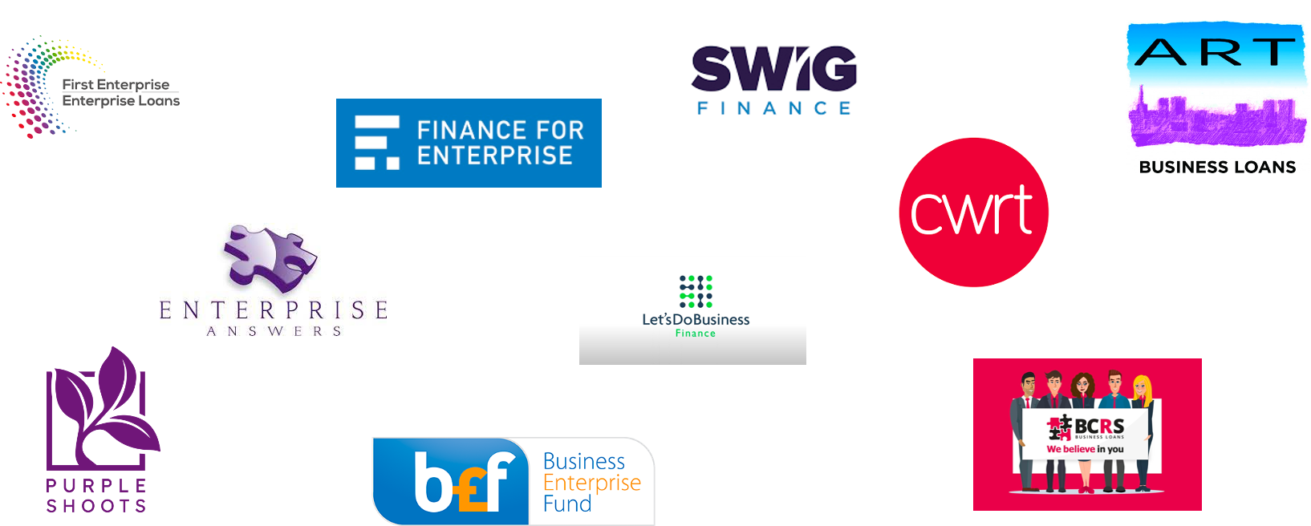
- How many years have they been operating for?
On average the sample CDFIs have been trading for 24 years:
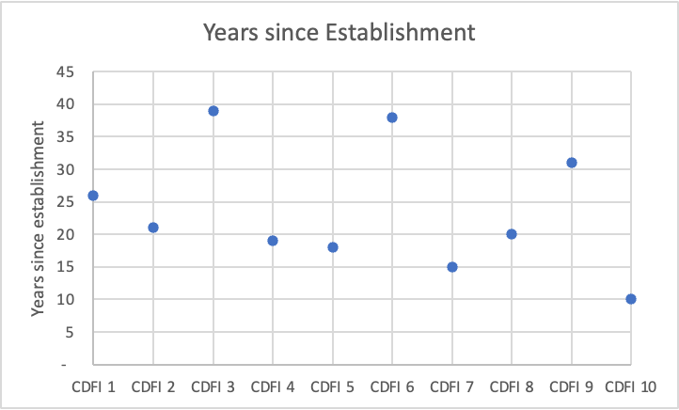

- What interest rates do CDFIs lend at?
The following graph shows the average rates on loans originated by the sample during 2022. The majority of loans rates are between 12% and 15%.
One small lender (CDFI 10) with annual originations of £200k lends small amounts to risker borrowers at much higher rates than is typical for other CDFIs.
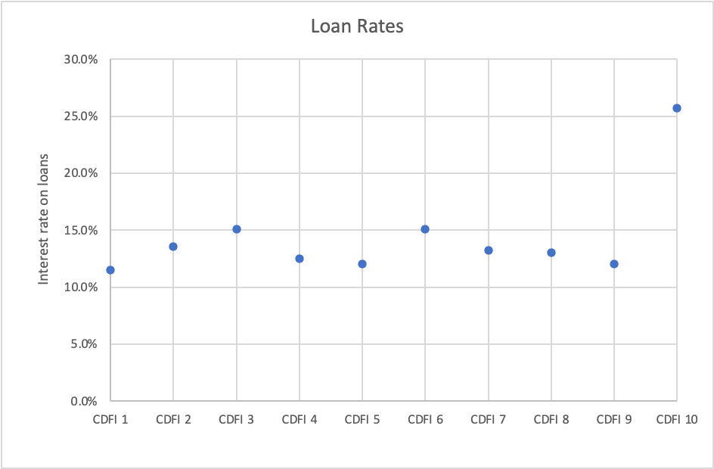

- What origination fees do CDFIs charge on loans?
In 2022 the average loan origination fee of the sample was 3.7% of the loan amount:

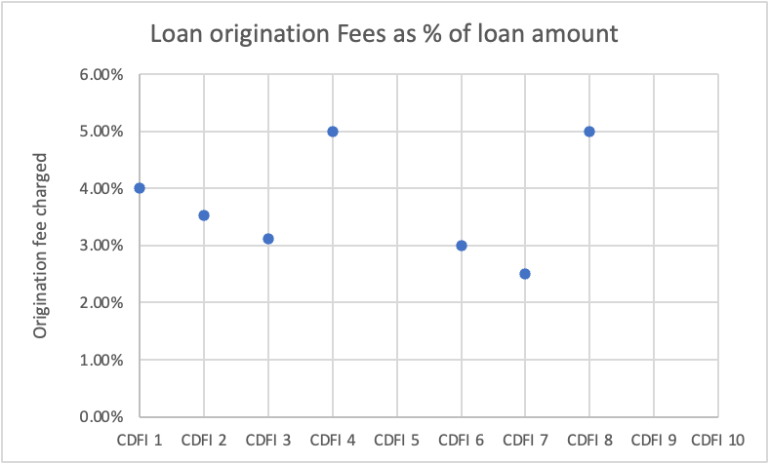

Note: 3 CDFIs did not report their origination fees

- What is the average term of a CDFI loan?
The majority of CDFI lenders offer 5 year loans to SMEs, with the exception of the small lender noted above:
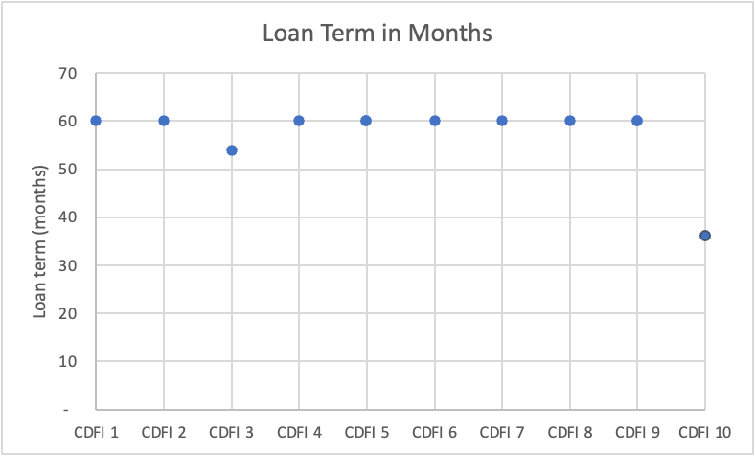
- What is the average CDFI loan size?
The overall weighted average loan size for this sample of CDFIs is £67,500 in 2022. The average loan size of the smallest lender was £2,700.

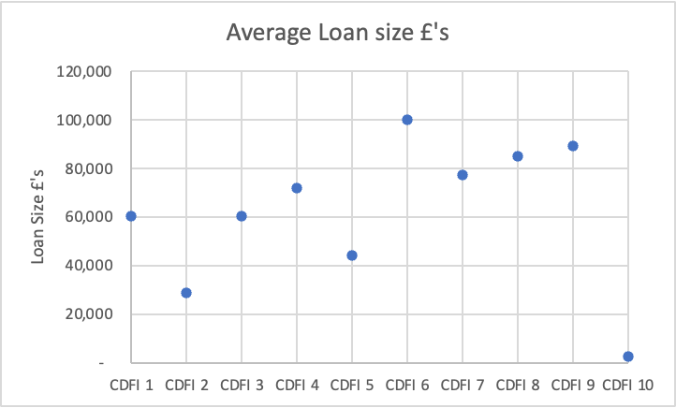

- How much do CDFIs lend each year?
The following graph shows how much was lent by CDFIs from their own balance sheets in 2022:

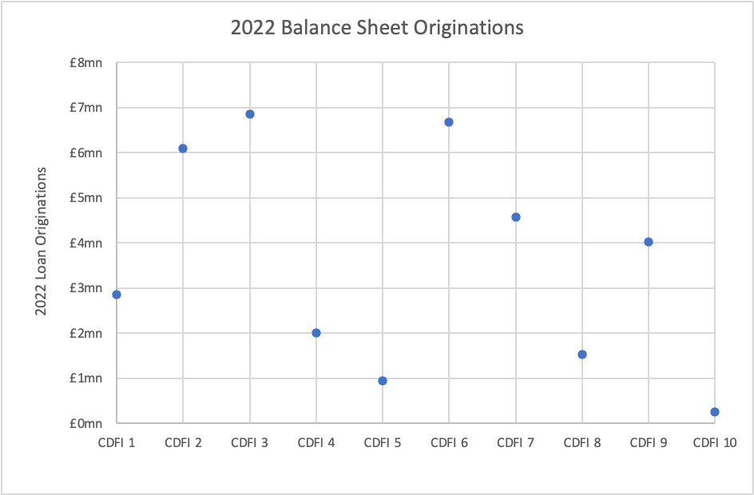

- What is the value of loans on CDFI balance sheets?

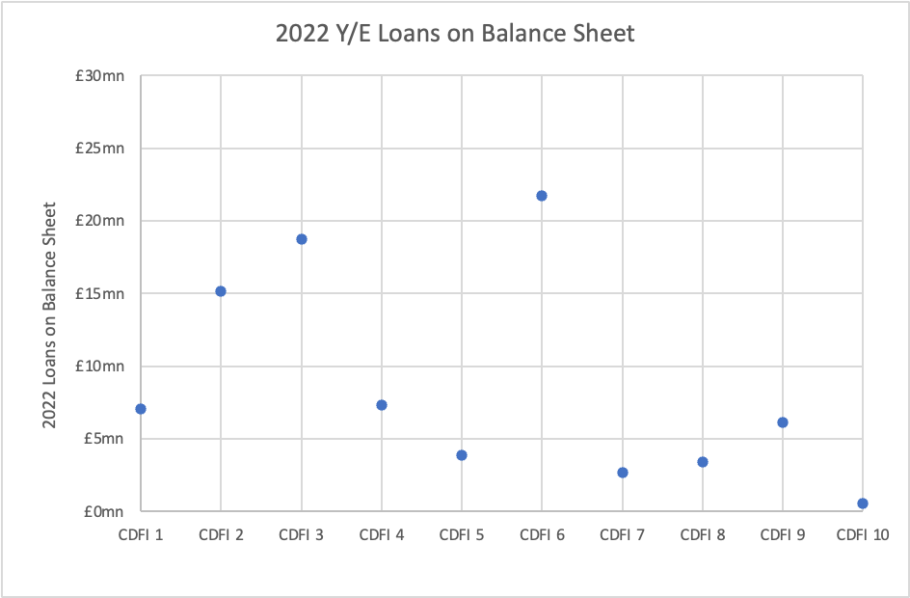

- How much external funding did CDFIs raise in 2022?

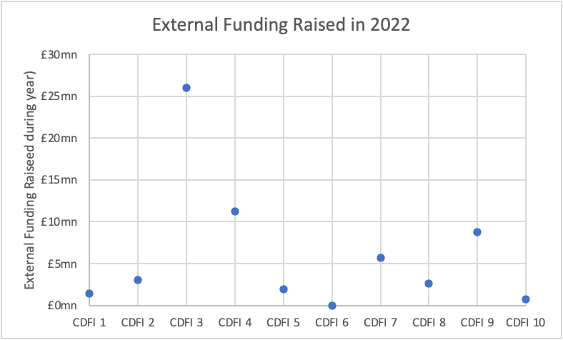

- Where did the external funding come from?

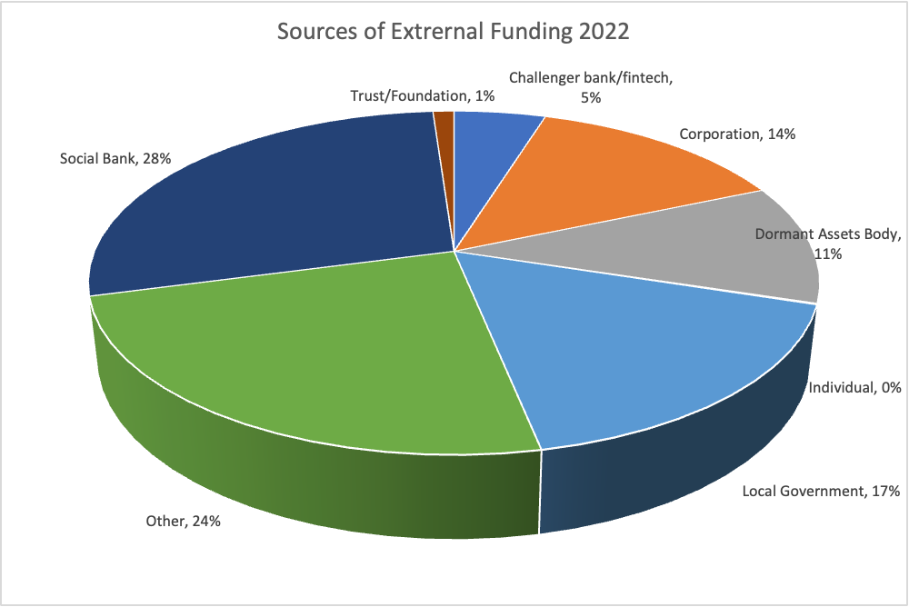

- What is their cost of funding?
The following table shows cost of funds for 7 CDFIs raised during 2022:

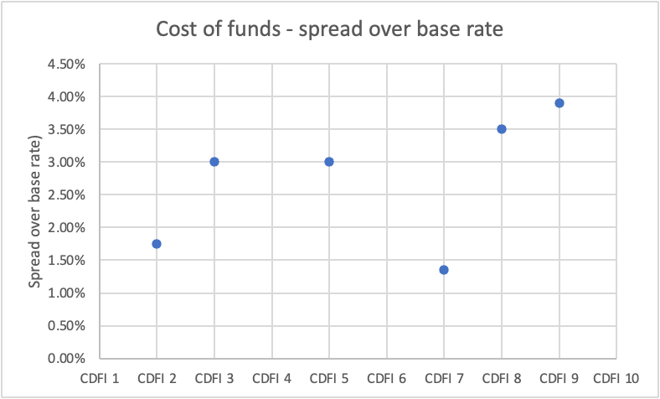

- What are the net interest margins of CDFI lenders?

Net Interest Margin = Interest Income less Interest Expense

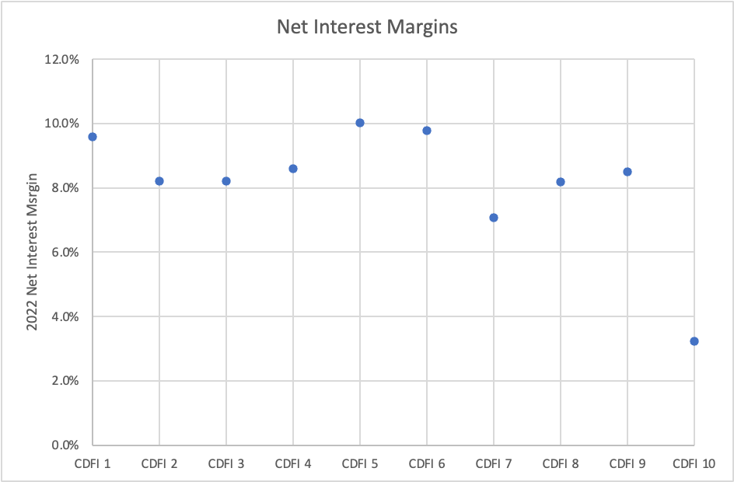

- What % of CDFI’s loans are more than 90 days in arrears?
The average % of loan portfolio in arrears > 90 days was 18% for the 5 CDFIs who responded to this question. A detailed analysis of loan arrears can be found in the latest review of the Community Investment Enterprise Facility.

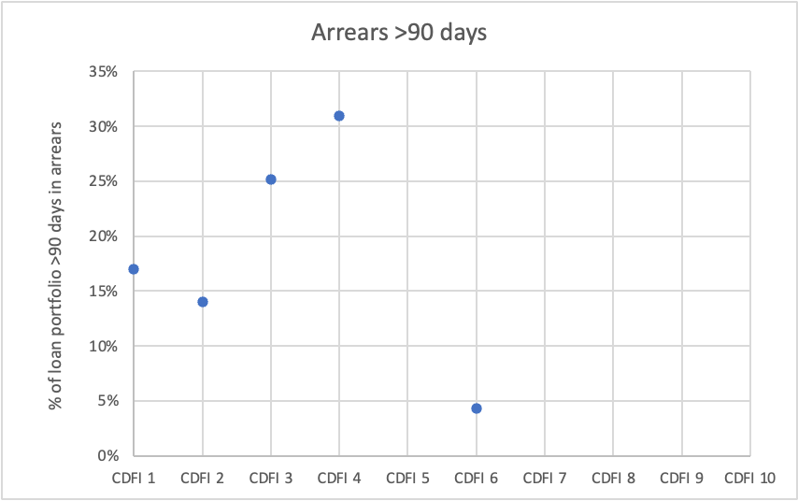
- What is the current level of loan loss provisioning?

The weighted average level of loan loss provisions is 8.2%.

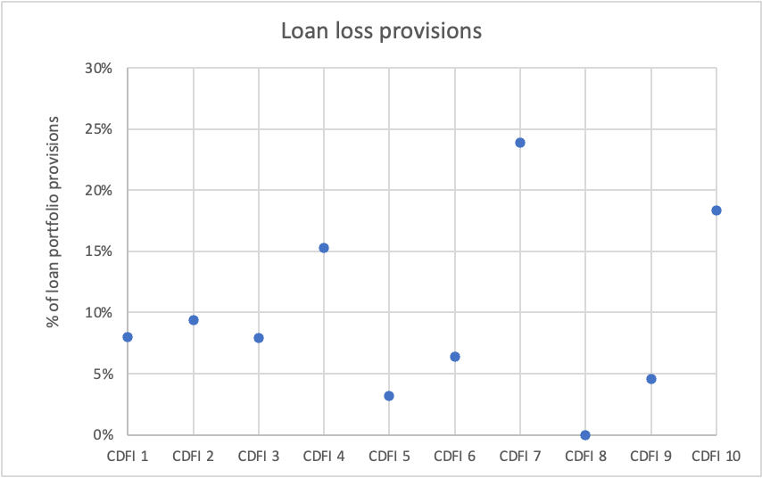

- What has been the cumulative bad debt write-off since establishment?
The weighted average bad debt write-off since CDFI establishment is 10.4%

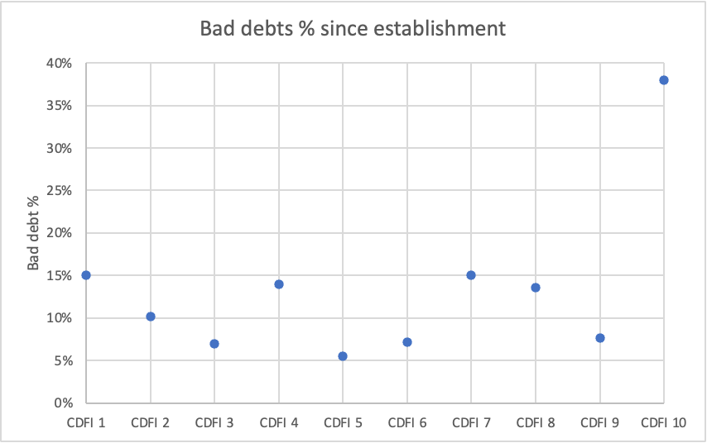

- How much use are CDFIs making of loan guarantees?
On average 78% of loan originations in 2022 were covered by the RLS guarantee.
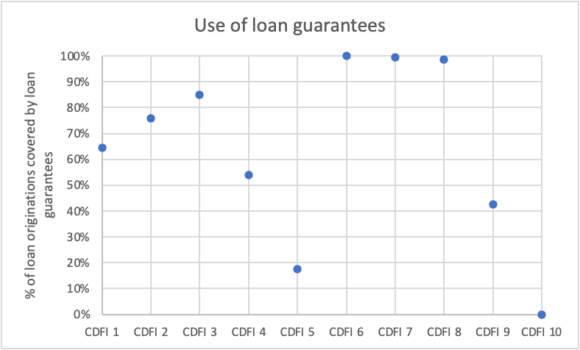

- How profitable were CDFIs in 2022?
In 2022 9 out of 10 CDFIs reported a positive return with an average profit of 3.6% of their loan portfolio. The profitability of CDFI 10 was boosted by the receipt of significant grants.

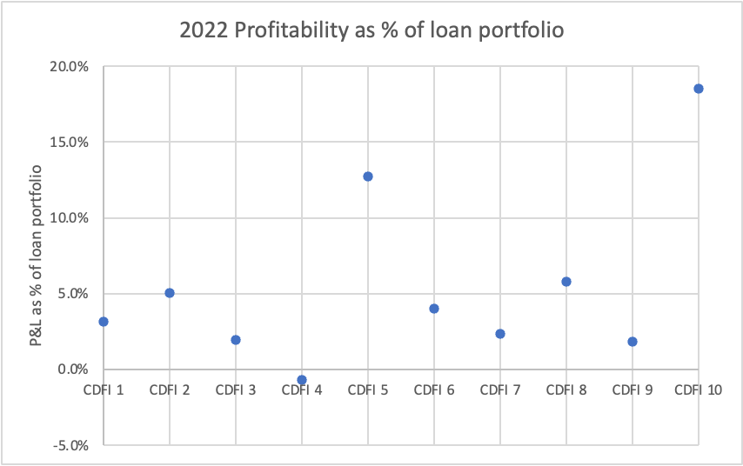

- What does a typical CDFI profit and loss account look like?
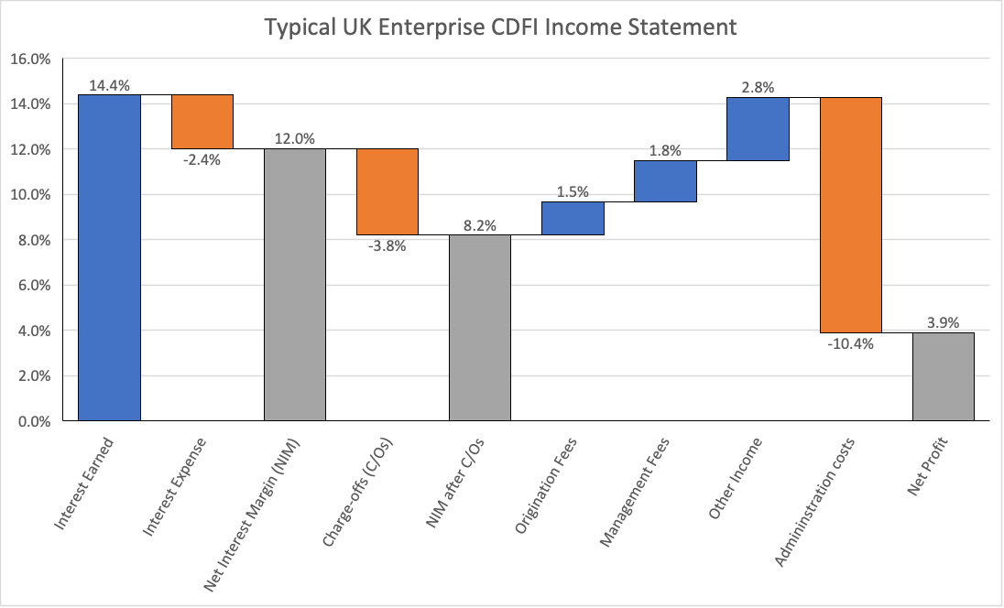

- What does a typical CDFI balance sheet look like?

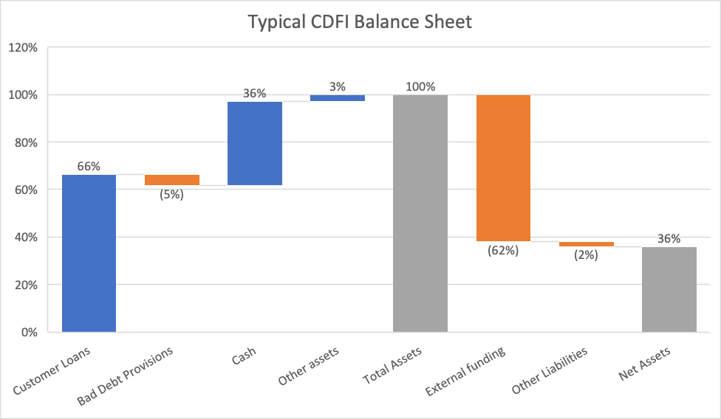

- Why do CDFIs have to hold so much cash?

The previous question illustrated that CDFIs hold a considerable proportion of their assets in cash. Appendix A provides a summary of published balance sheet data for the 10 CDFIs used in this report. On average they hold 36% of their assets in cash.

Reasons why CDFIs hold so much cash include:

- As pool of liquidity for future lending
- To protect against increased bad debts
- Because of structural constraints (e.g CITR reinvestment)
- Due to restrictions on lending
- To provide security for lenders
- As a reserve against future administration costs/wind-down provision

- How do UK business lending CDFIs compare to those in the US?

The following table provides a comparison of UK and US CDFIs who specialise in lending to small businesses. The US data is drawn from the OFN Side-By-Side Survey 2021:

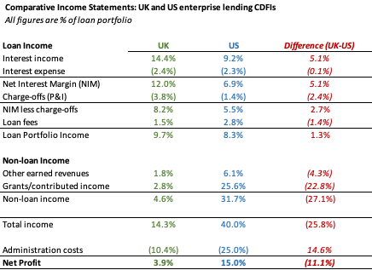

A number of differences can be observed:
- UK lenders achieve higher Net Interest Margins than their US counterparts, but this is offset to some degree by high charge-offs.
- US lenders attract much higher levels of grant support than UK CDFIs.
- US lenders achieve higher net profits, but this is primarily due to much higher levels of grants.

The following graph shows the comparative balance sheet ratios of US and UK CDFIs:

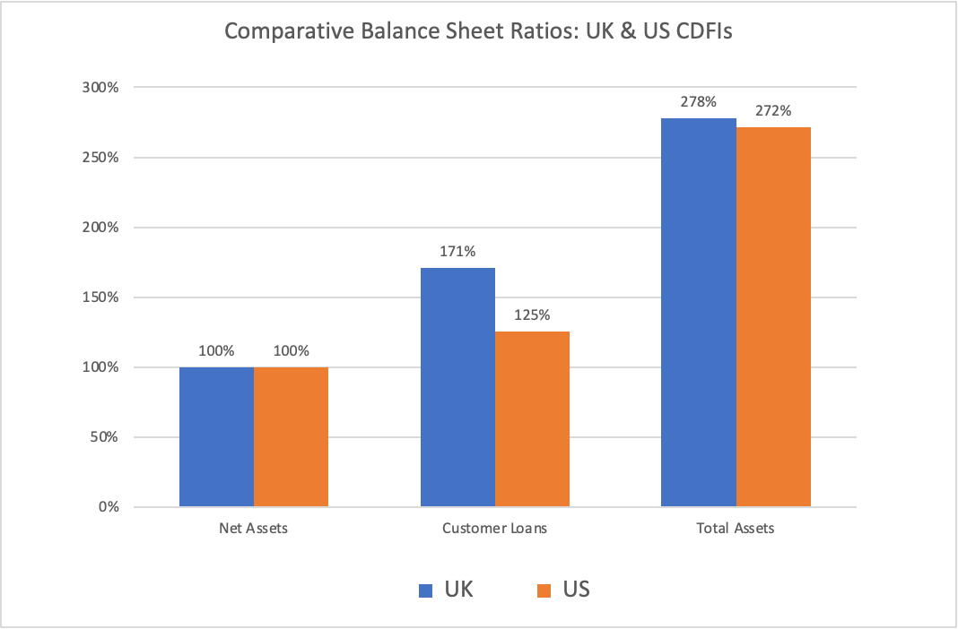

Appendix A: A Summary of Balance Sheet Accounts From Published Accounts

Note: The majority of data is drawn from accounts published with a year end in 2022.

https://www.communityinvestment.co.uk/wp-content/uploads/2022/12/CISG_Evaluation-of-the-Community-Investment-Enterprise-Facility_2022_05_FINAL-1-2.pdf
https://cdn.ofn.org/uploads/2023/01/05152611/Side-by-Side_FY2021.pdf pages 29-31

